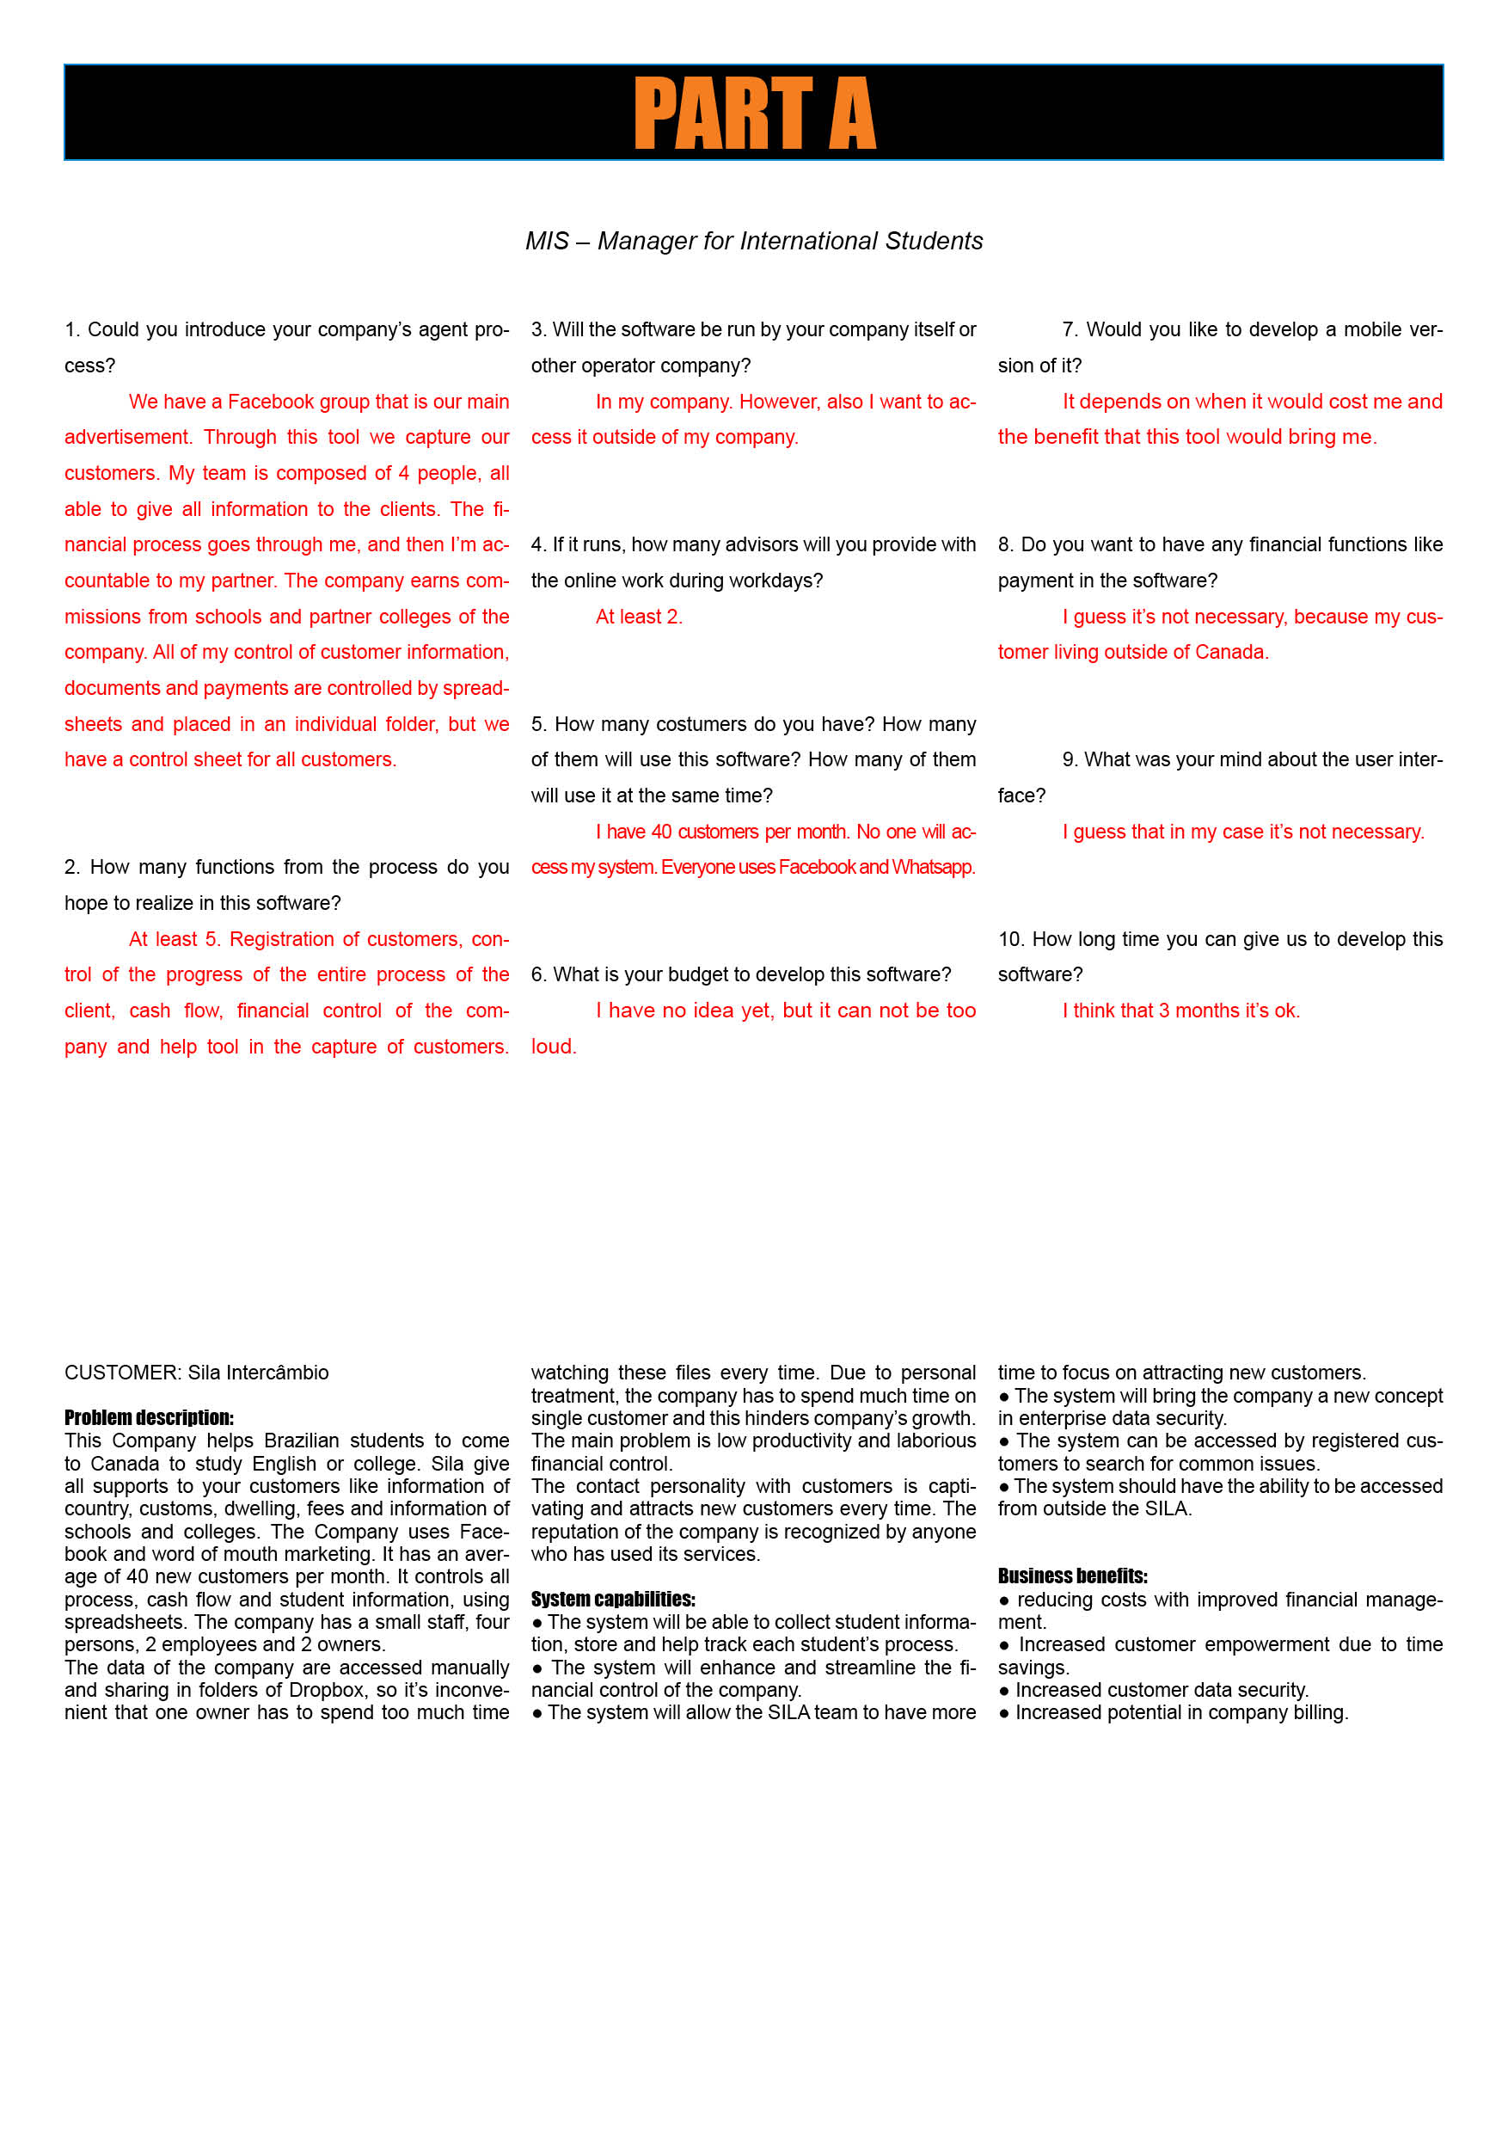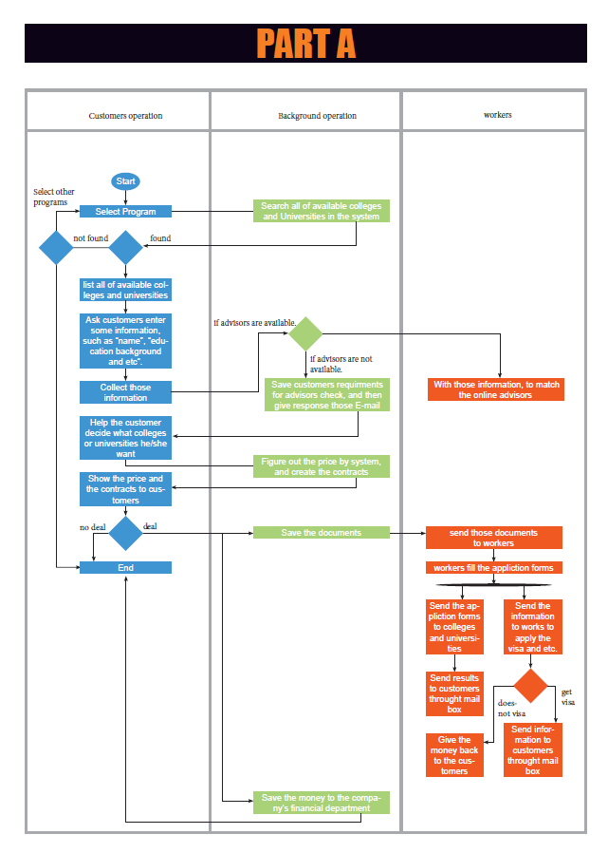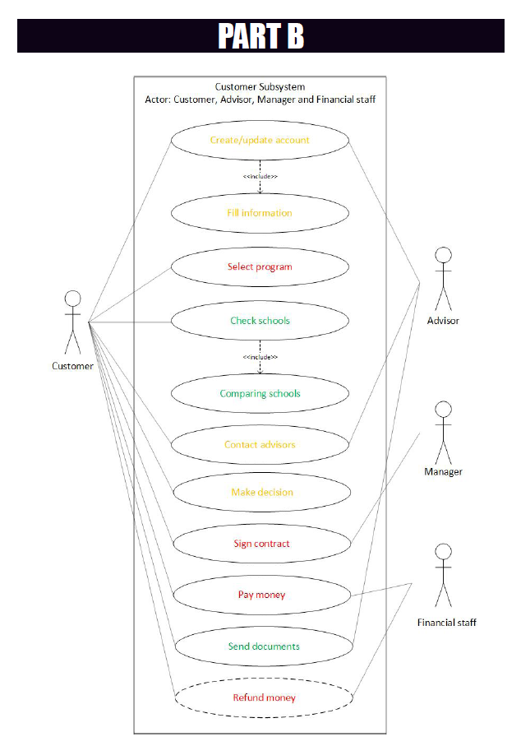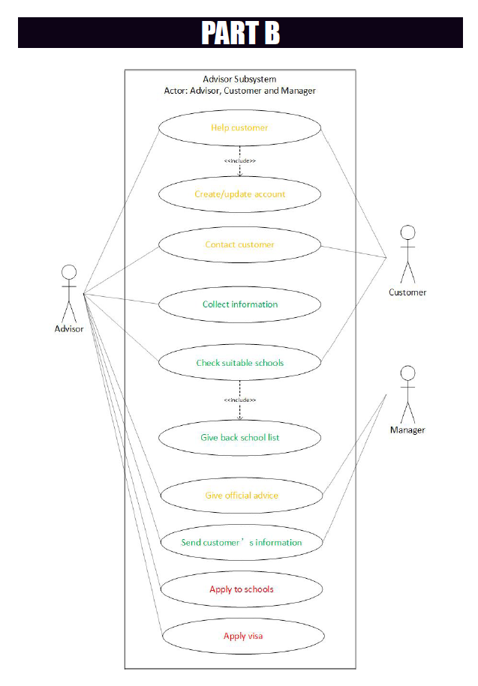

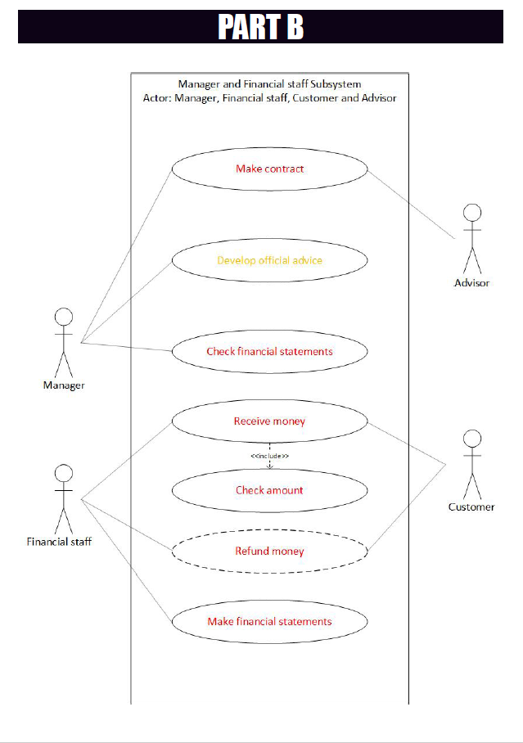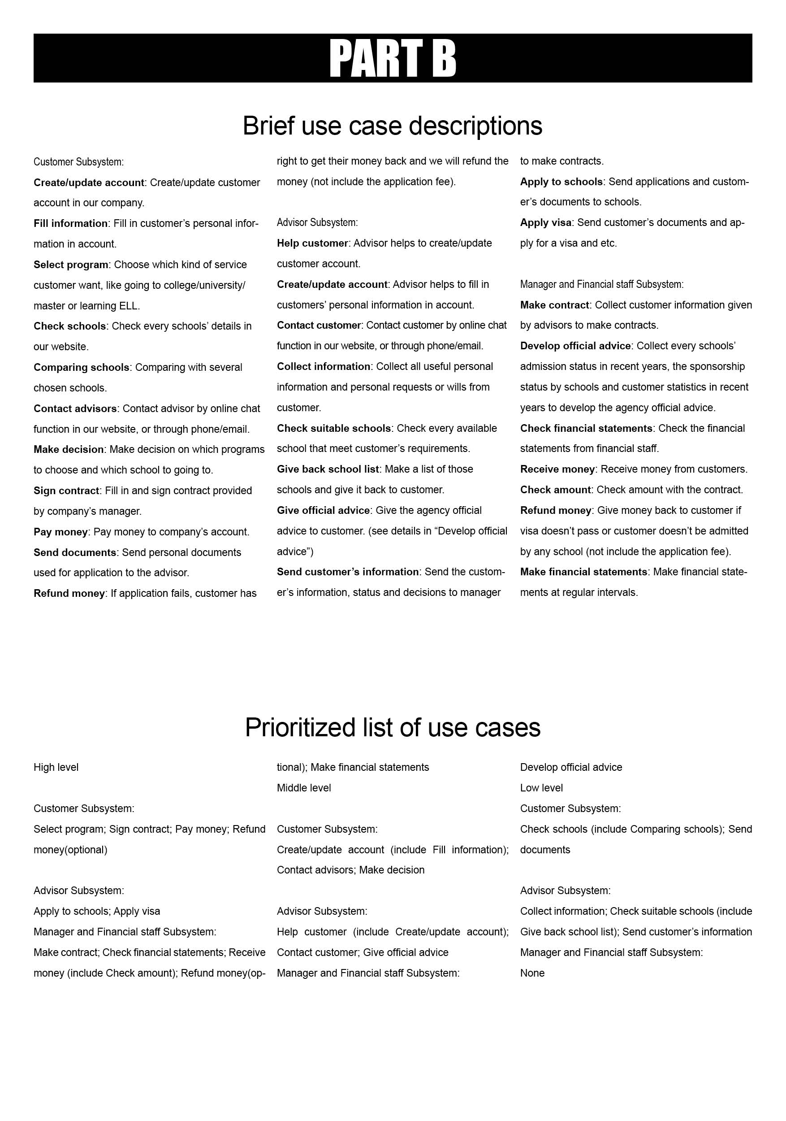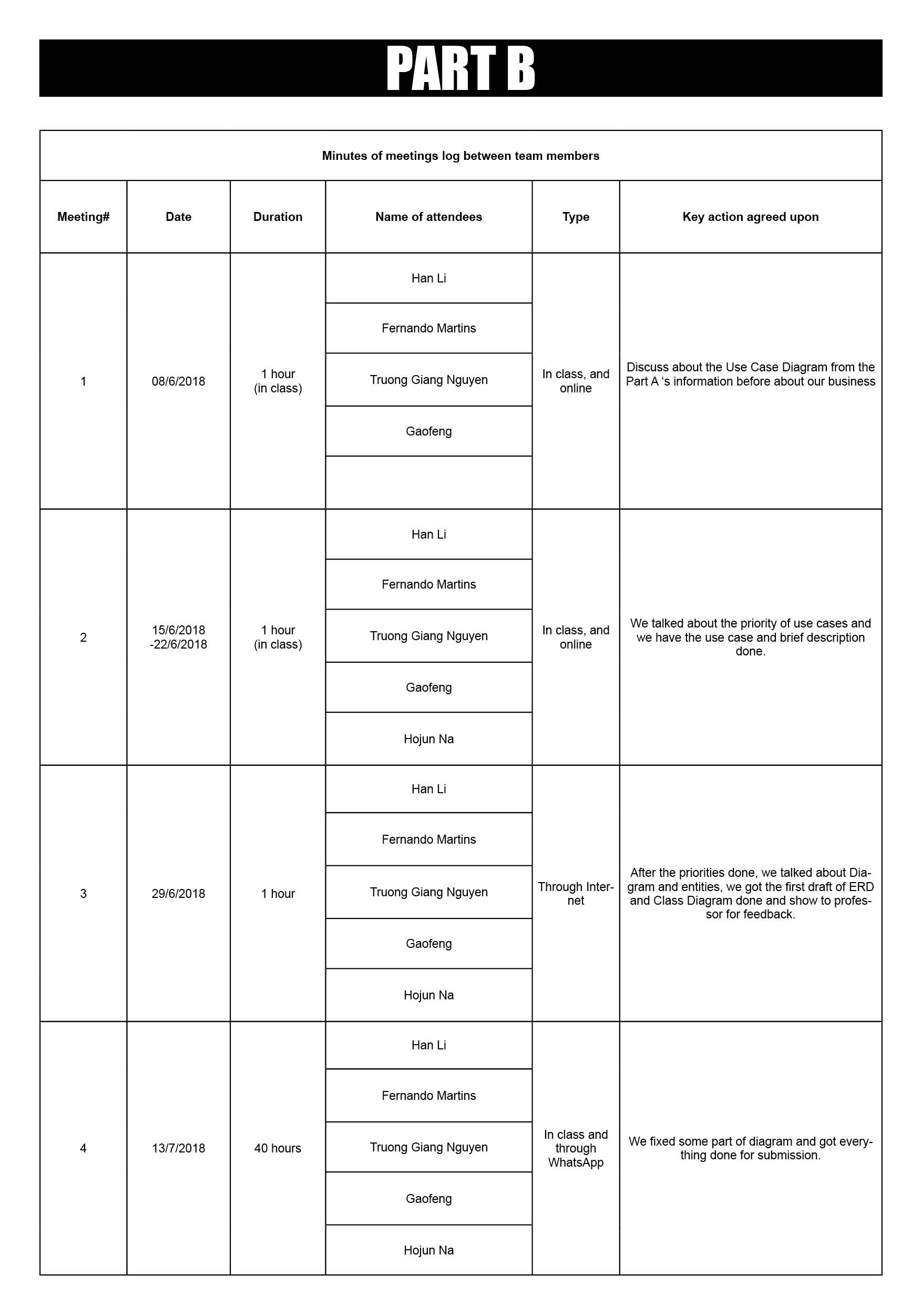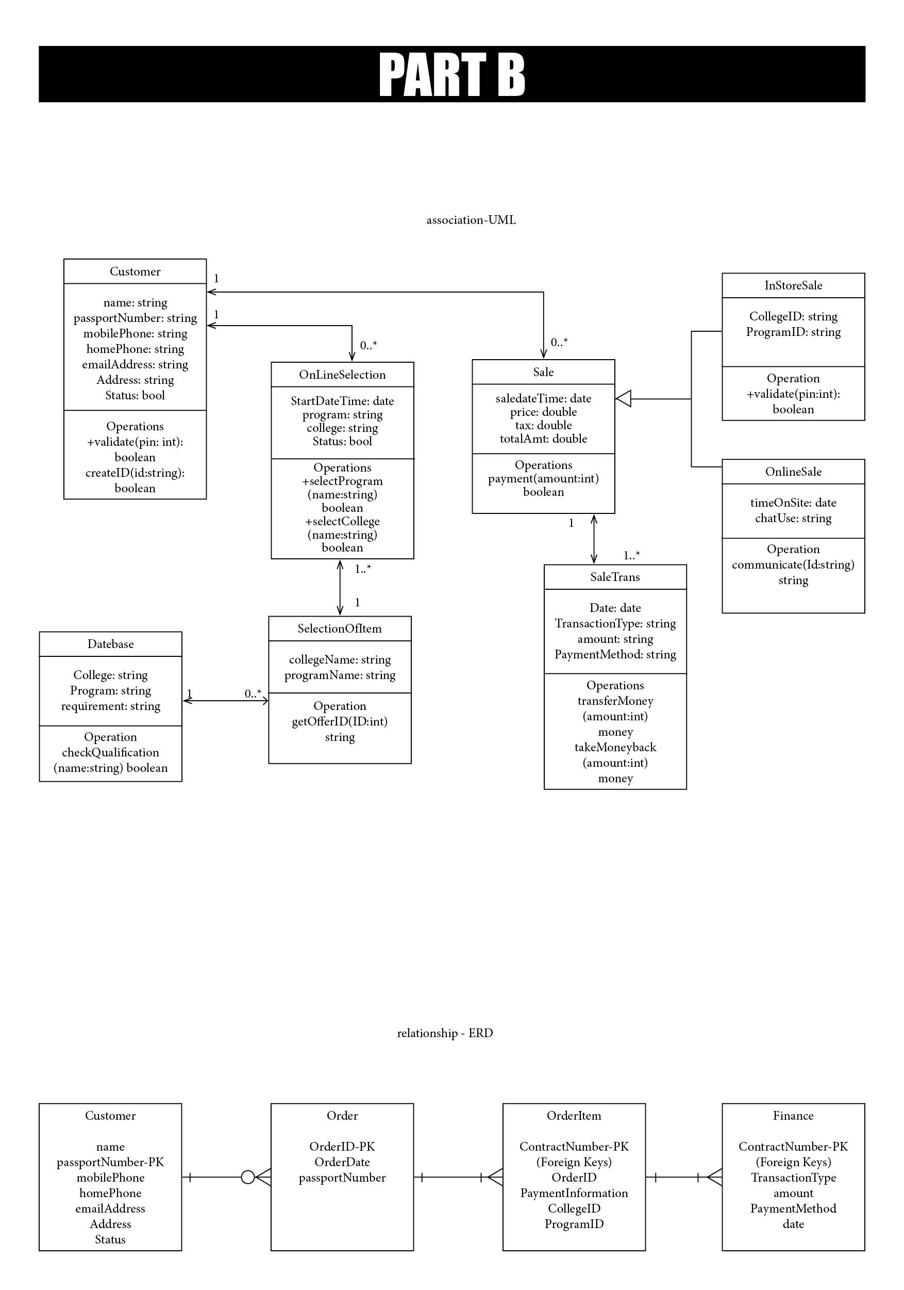

PART C

1.Add at least 2 methods to each class in the Domain class model you developed in part B.

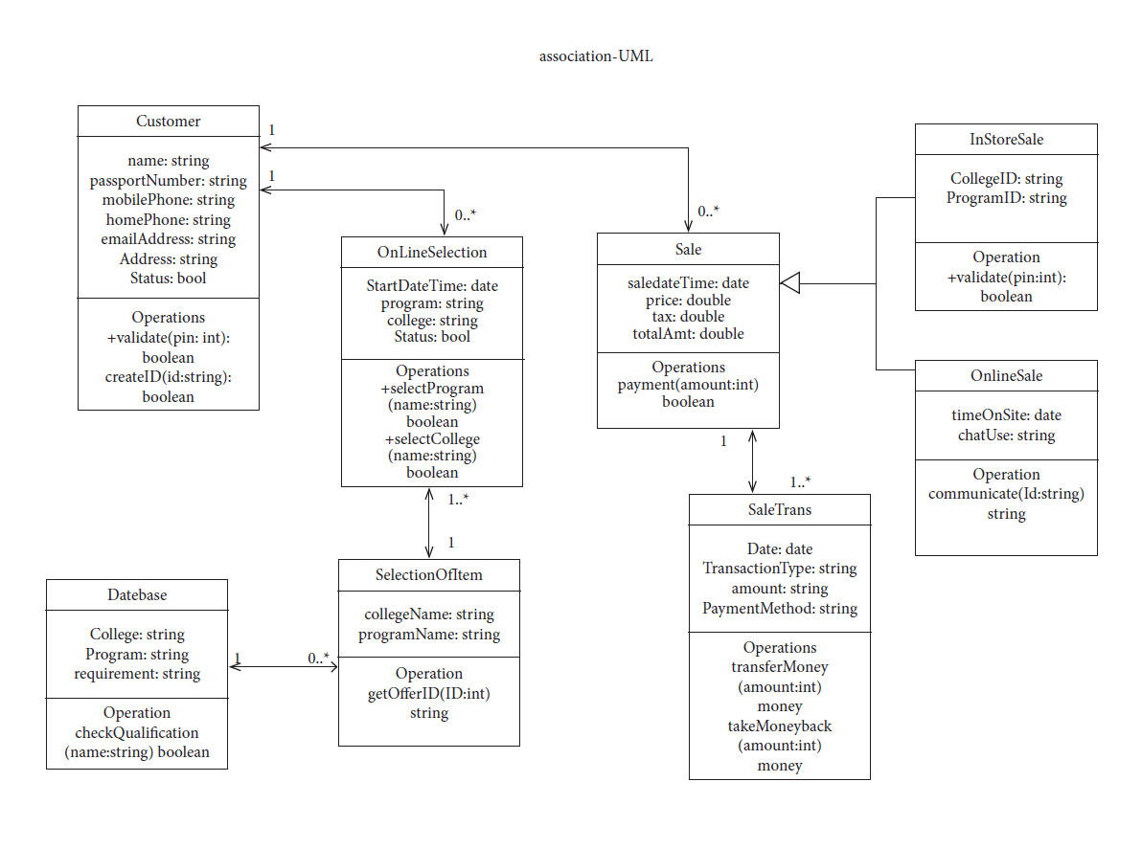

2.Use Case full description form / Users’ Stories

Here we are talking about a fully developed users’ story and a fully developed use case description.

**Background:**

Viji is a student in Brazil just graduated from a high school. She wants to come to Canada for further study. She would like to learn about software.

One day she found our company through Internet. She made her first call to us and decided to choose our company to help her.

**Processes:**

Firstly, she goes to our website to create an account. This process includes filling her personal information.

Then she must select a program. This is our first high level priority use case. We provide many programs for customer to choose like going to college (includes diploma, degree, certificate…), university (bachelor degree, master degree, doctor degree), ELL (different levels) …… Each program contains almost every accessible schools in different cities.

Viji wants to study software and get a 3 years diploma in one college in Toronto. So, she can choose Toronto – college – diploma – software.

Our system will list all software majors in every accessible college in Toronto as soon as possible for Viji to check and compare (Every detail about schools and majors will be contained).

After that she contacts with one of our advisors - Narendra by randomly through online chat function in our website. (phone/email are also available)

Meanwhile our advisor Narendra has set up one-to-one correspondence with customer Viji. Now he is able to view Viji’s account, he will collect useful information and talk to her to know personal requests and wills.

Then Narendra will check every available school that meets Viji’s requirements, make a list of those schools and give the agency official advice to customer.

Viji makes a decision on going to Centennial College to learn Software Engineering Technology.

Advisor Narendra sends Viji’s information and decision to company manager – Jake. Jake makes a contract and sign it firstly, then gives it to Narendra. Narendra also must sign it.

Now customer Viji has two choices – one is going to our office in Brazil to sign contract and make payment face to face. Two is doing these things through Internet. She selects the second way: sign in the PDF contract online and make payment by PayPal.

The financial staff – Mayy in our company receives the money and checks amount with contract.

Until now the contract starts, and company has received money from customer. Narendra will send Viji a list of documents she should provide for application of school and visa, give her some time to prepare for them. After a few days, Viji will post them to company.

Narendra helps to write application letter, binds documents and posts them to school.

As soon as gets offer, Narendra will post documents including the offer to Embassy of Canada for visa.

**Regular work:**

As the manager, Jake ought to have right to control the whole company. It includes all advisor’s work. To avoid some inexperienced advisors giving out unsuitable advice. Jake should develop an agency official advice. It is based on every schools’ admission status in recent years, the sponsorship status by schools, customer statistics in recent years and so on.

Jake also has to check the financial statements regularly. They are made by Mayy – the financial staff at regular intervals.

**Non-essential work:**

If visa doesn't pass or customer Viji doesn't be admitted by any school, she has right to get her money back. The financial staff Mayy will refund the money. (not include the application fee)

3.System Sequence Diagrams and State Machine Diagrams

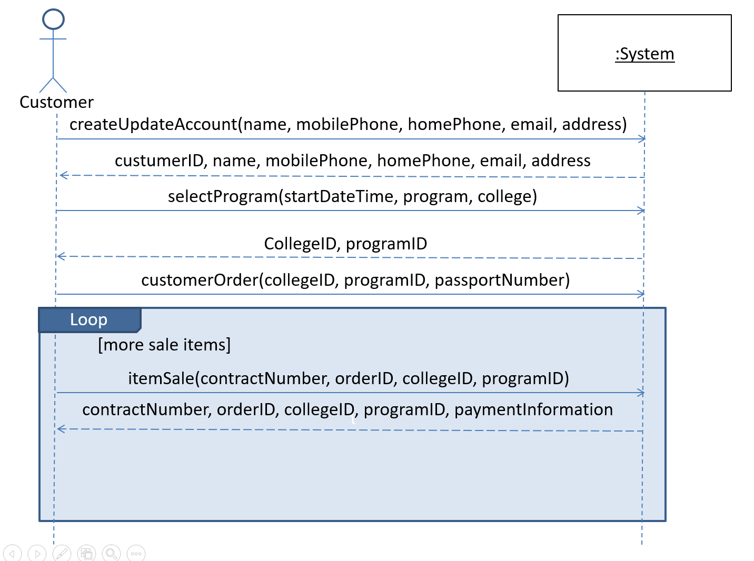

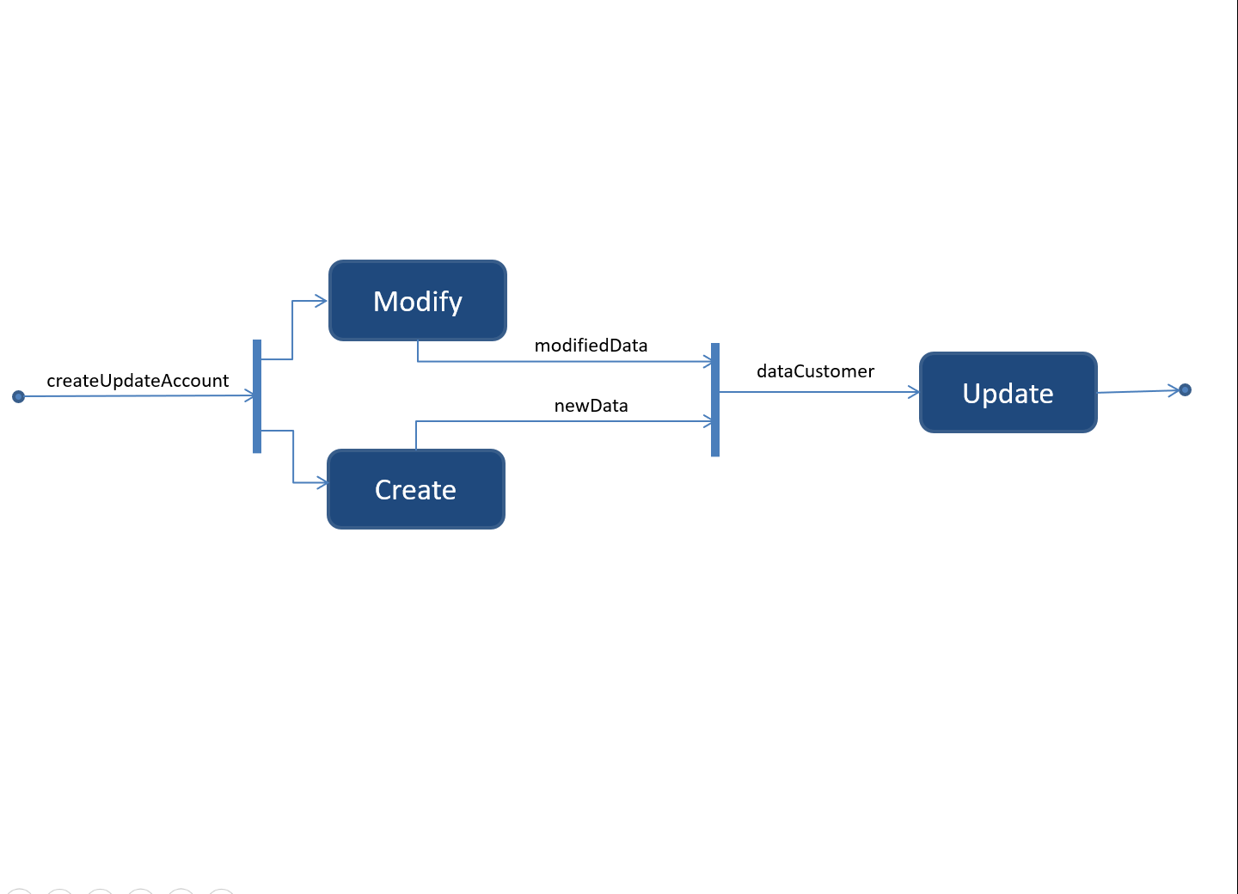

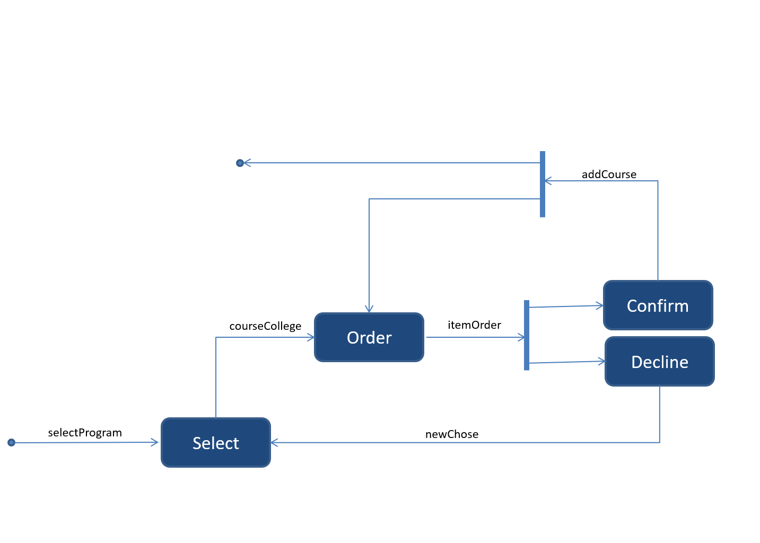

4. Gantt chart

